**Project Title:**

**Objective:** The Local Exam System is designed to provide a seamless and flexible digital learning platform for educational institutions, enhancing the teaching and learning process for both teachers and students. The software aims to make the online education experience more accessible and engaging by offering user-friendly features that simplify exam creation, participation, and evaluation. By streamlining these processes, the system promotes efficiency in educational workflows, encourages the adoption of online learning, and fosters a more interactive and adaptable learning environment. The goal is to ensure both educators and learners benefit from a smooth and intuitive experience that motivates continued use and interest in digital education.

**Tools and Languages:**

**Python**:

**Programming Language**: Python was chosen for this project due to its simplicity, versatility, and wide range of libraries that are well-suited for GUI development and data management.

**Tkinter**:

**Graphical User Interface (GUI) Library**: Tkinter is a standard Python library used to create desktop applications. It was used to design and implement the user interface, allowing for the creation of windows, buttons, labels, and input fields, which form the core interaction points for both students and teachers in the MCQ system.

**JSON**:

**Data Storage Format**: JSON (JavaScript Object Notation) is used to store and manage data for this project. It is a lightweight and human-readable format that stores information such as user credentials, exam questions, student scores, and results. JSON files are easy to read, write, and manipulate using Python’s built-in json module, making them suitable for this local system. JSON acts as the primary storage mechanism for storing exam data, user information, and exam results.

**Features:**

**Teacher Panel**:

1. **Exam Creation**: Teachers can create new exams by entering the exam title, duration, and number of questions.
2. **Question Addition**:After creating the exam, teachers can seamlessly add multiple-choice questions, set the correct answers, and save them.
3. **Edit Exams**: Teachers can view and edit existing exams, modify questions, and update exam settings.
4. **View Result**:Teacher can see students participation and marks in his profile .

**Student Panel**:

1. **Exam Selection**: Students can view a list of available exams and select any exam to attempt.
2. **Question Display**: The system presents MCQ questions one by one for the student to answer.
3. **Answer Submission**: Students can submit their answers via a submit button, which records their responses.
4. **Real-Time Countdown Timer**: A countdown timer is displayed during the exam, ensuring that students complete the exam within the allotted time.
5. **Score Display**: After submitting the exam, students are shown their obtained marks along with a congratulatory message if they perform well.

**Screenshots:**

1.

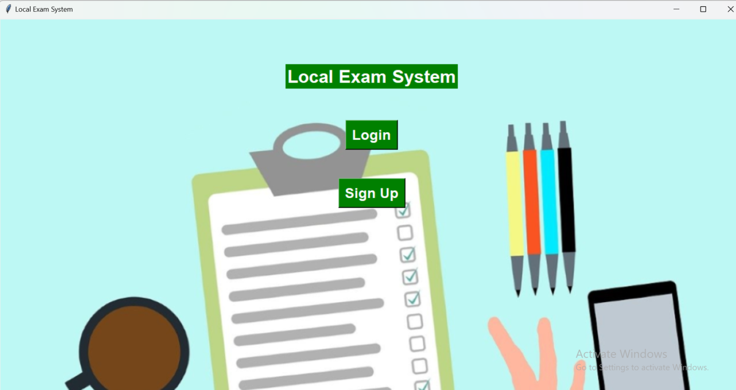

2. Sign-In Page

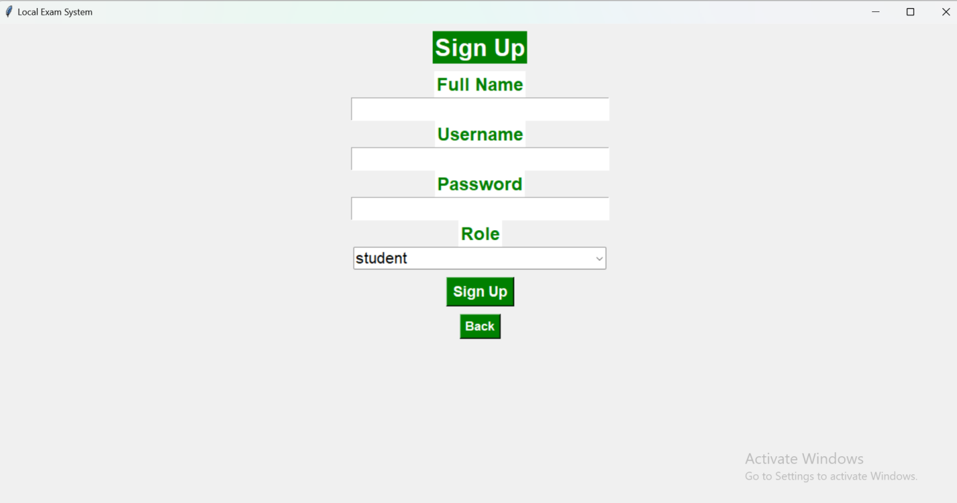

3. Login Page

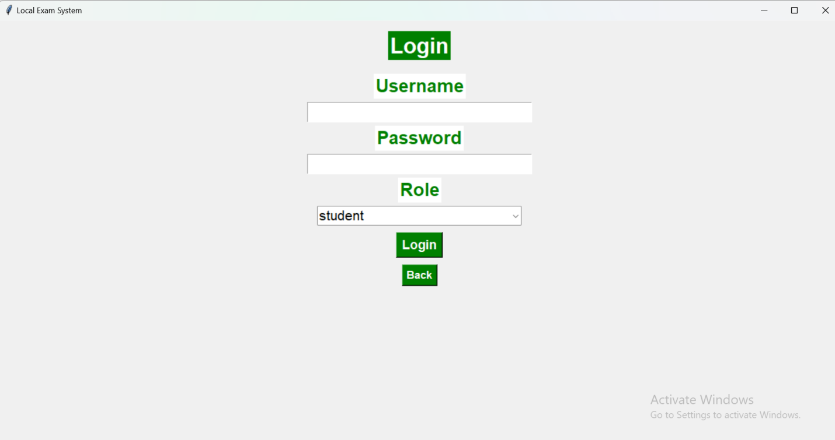

4. **Student's Dashboard**

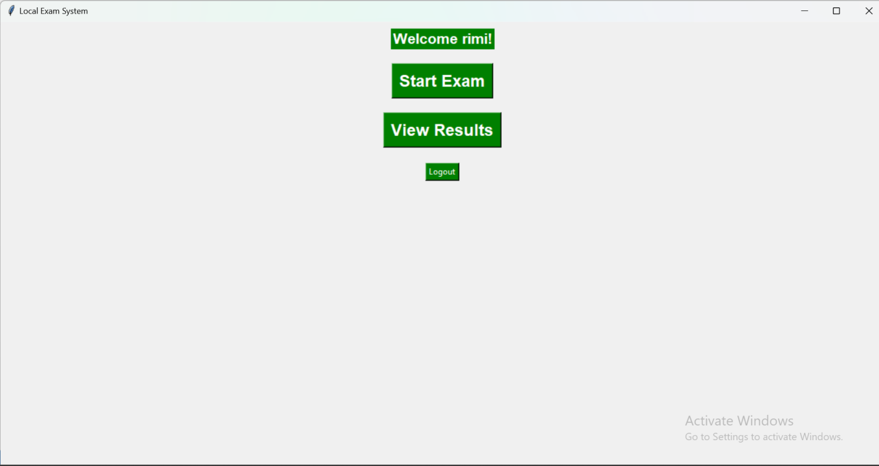

6.Teacher's Dashboard

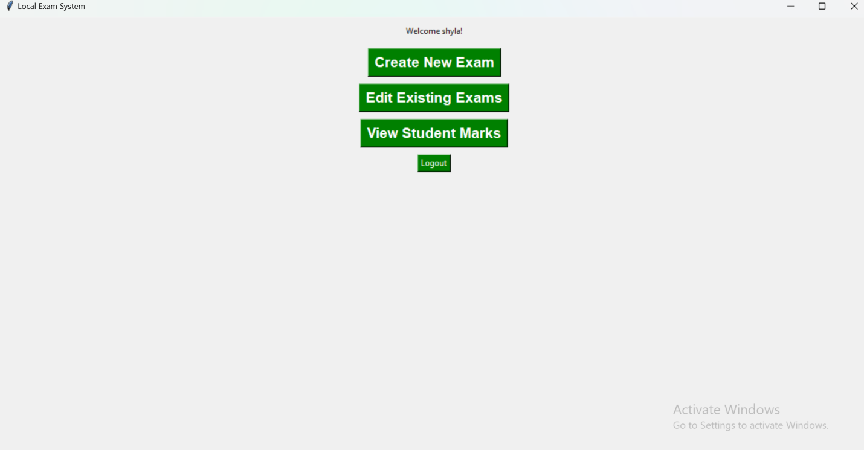

**Conclusion:** The development of the Local Multiple Choice Question (MCQ) System using Python and Tkinter has effectively created a user-friendly platform for both teachers and students. The project has achieved several key outcomes, including User-Friendly Interface,Comprehensive Exam Management,Efficient Examination Process,Robust Data Handling,Scalability and Flexibility.Additionally, the system's compatibility with multiple platforms (Windows, macOS, Linux) ensures accessibility for a wide range of users. Its offline functionality allows for use without an internet connection, with all data stored locally on the machine. This enhances the system's practicality and convenience in various educational settings.